TASK 1: CLEANING AND PREPARATION OF DATA
- DATA EXTRACTION AND TRANSFORMATION
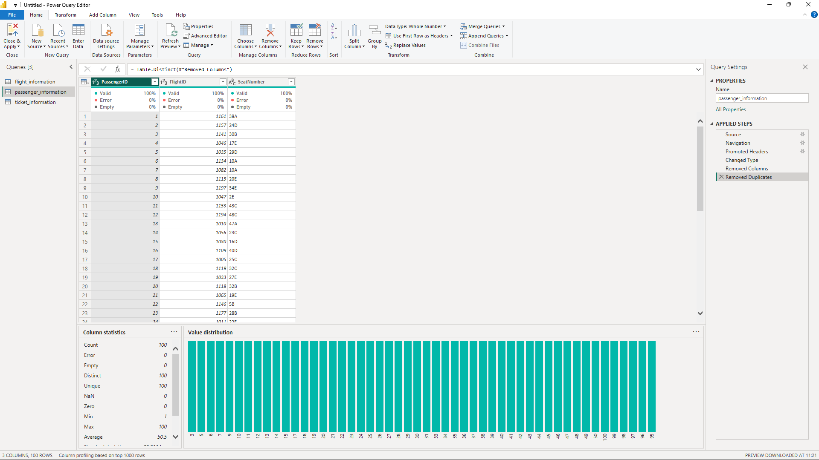
- DATA CLEANING
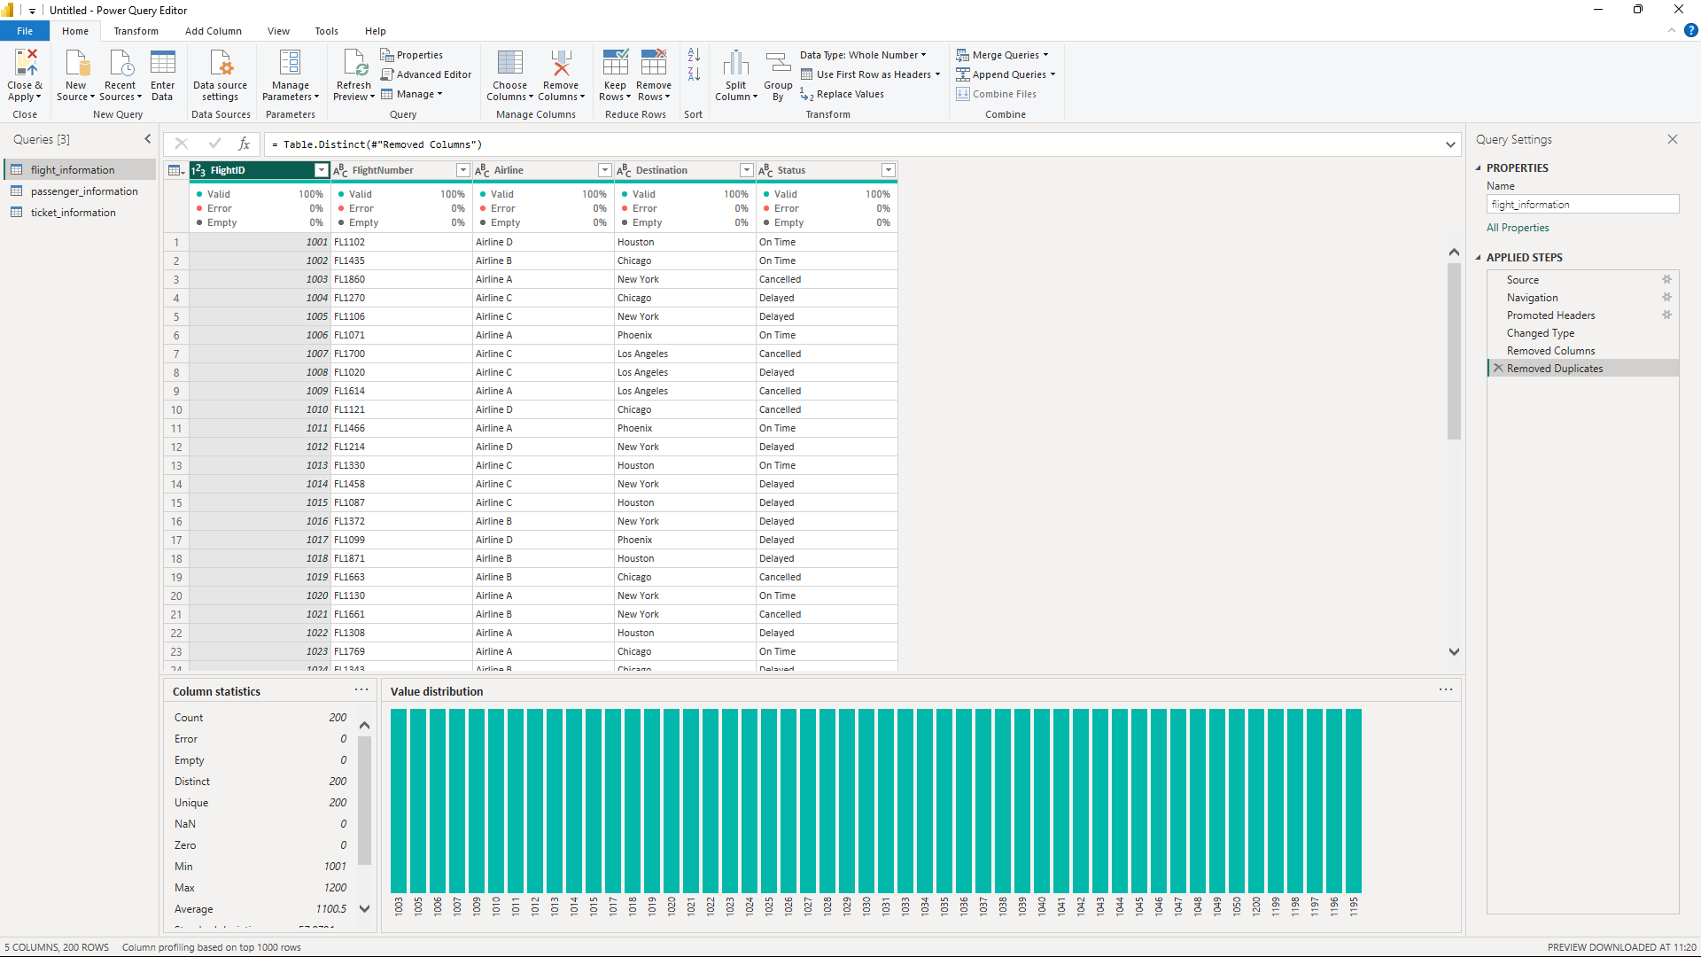
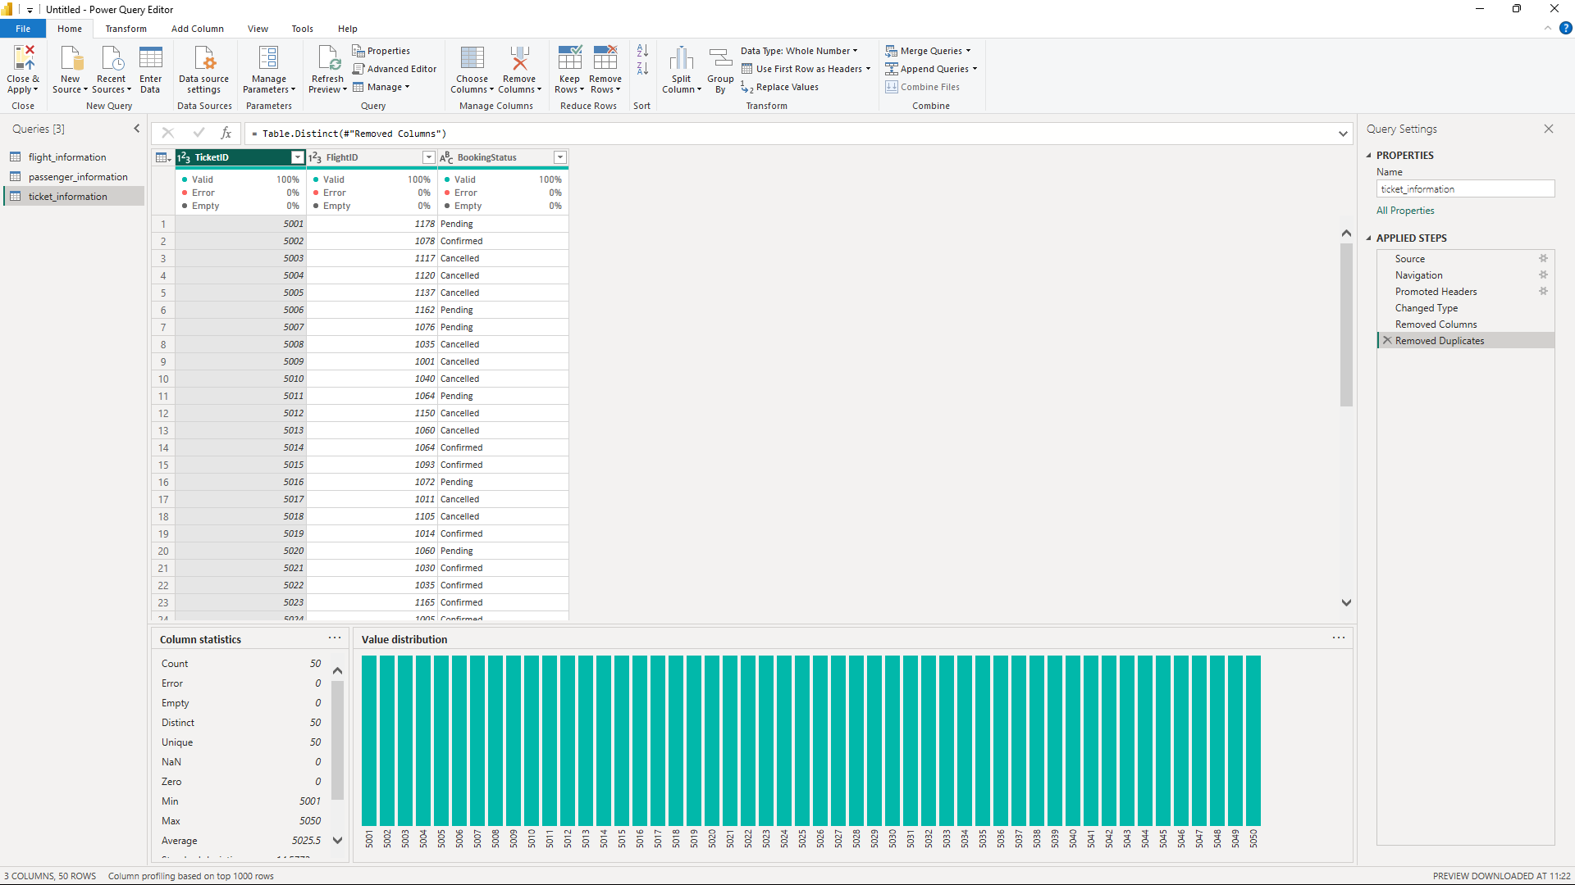
TASK 2: DATA MODELLING
RELATIONSHIP AND CARDINALITY: ONE TO MANY
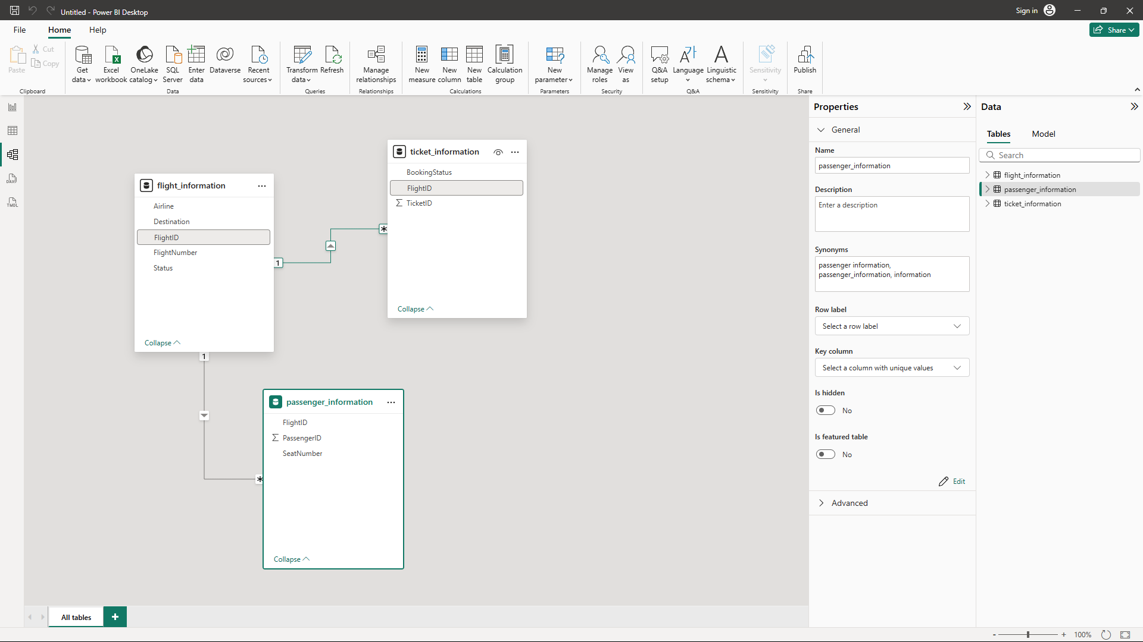

TASK 3: ENHANCE DATA INSIGHTS
1.CONDITIONAL COLUMN
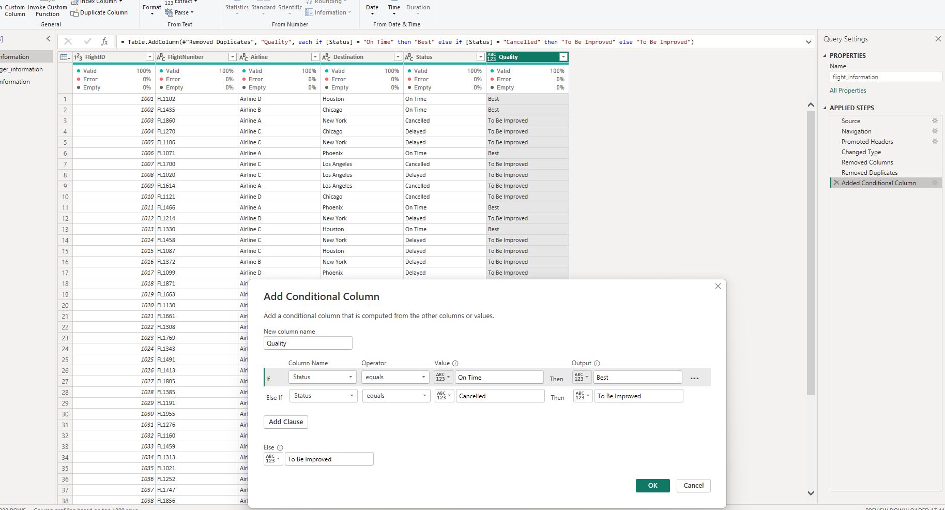
2.COLUMN FROM EXAMPLES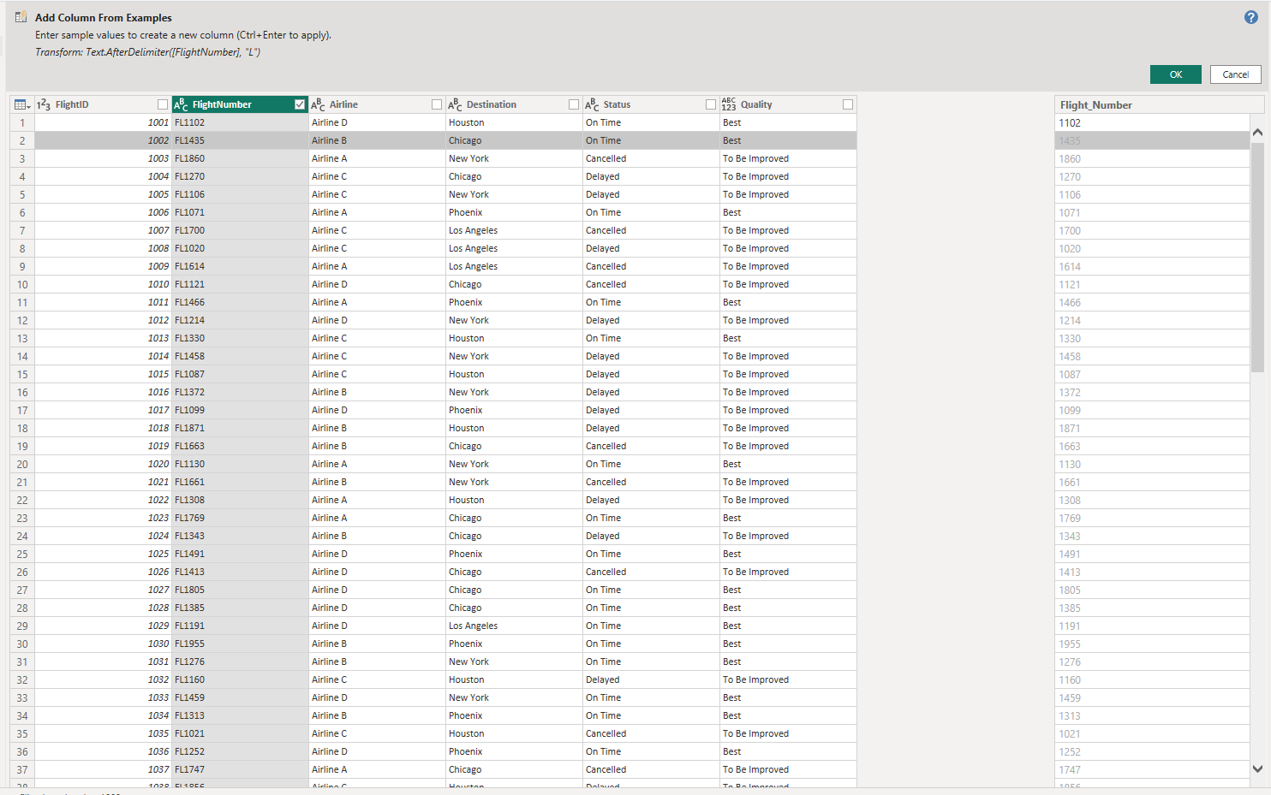
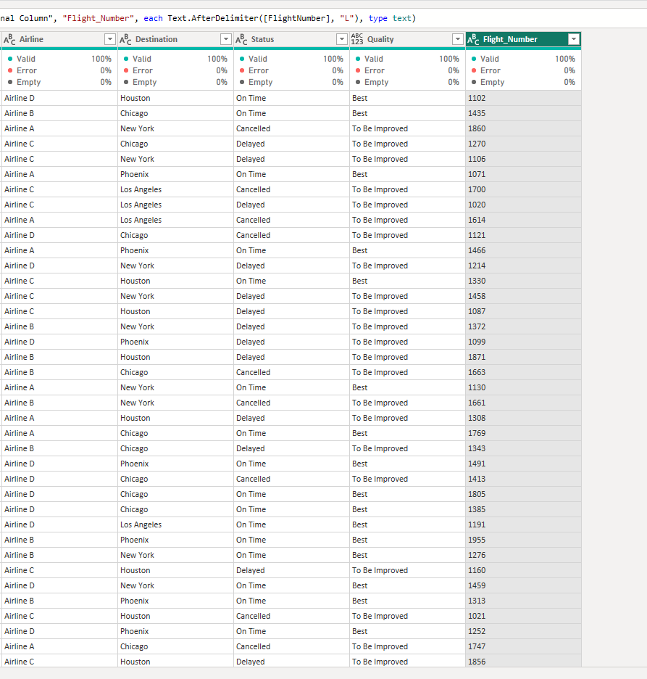

TASK 4: CALCULATION USING DAX
- TOTAL TICKETS BOOKED.
2. TOTAL PASSANGER FOR A SPECIFIC FLIGHT 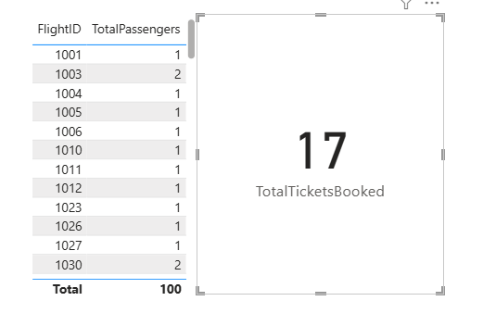
3.SHOWING ONLY “BEST” FLIGHTS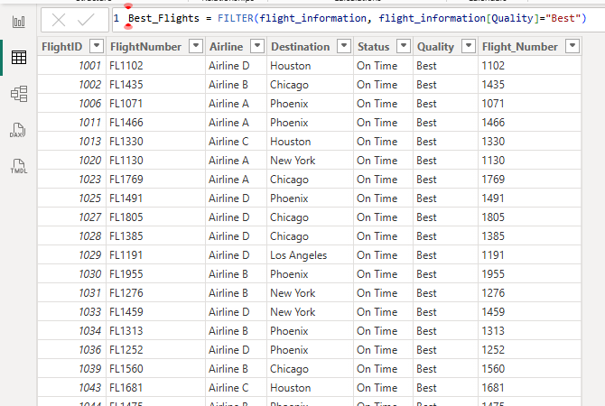
TASK 5: VISUALIZATION AND INTERACTIVE FEATURES
FOR VISUALS:
1. Passenger count by airline. 2. Ticket booking statuses. 3. Flights by airline and destination.
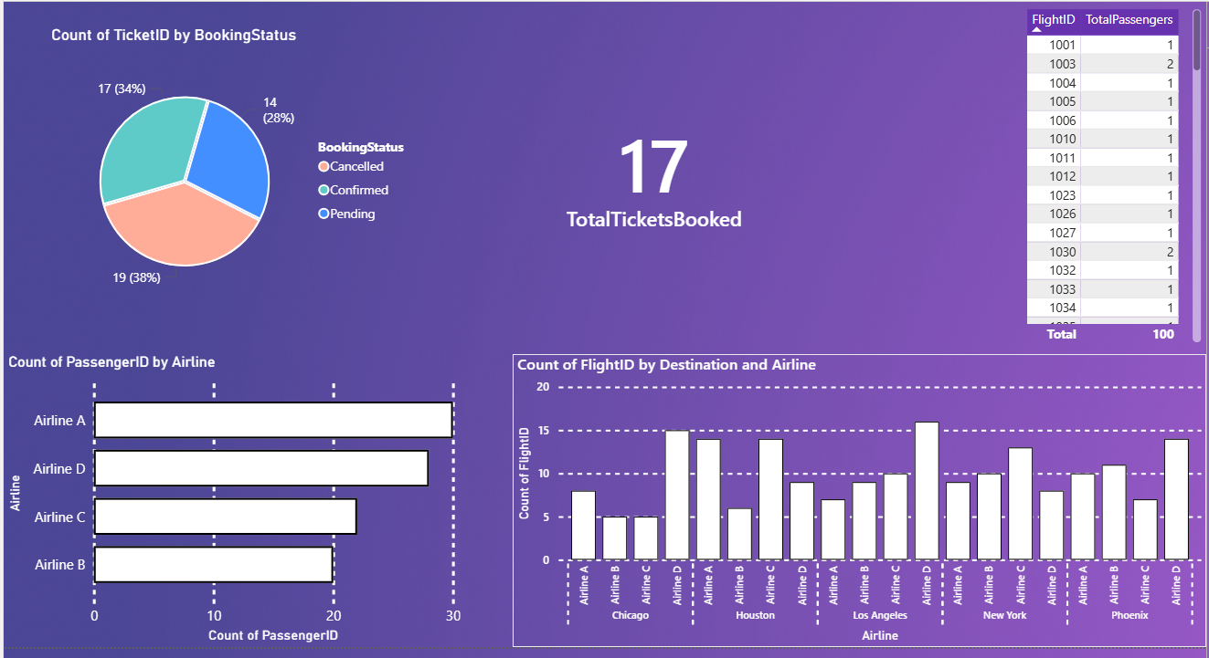

FOR INTERACTIVE FEATURES:
1. Destination and Airline. 2. Quick Views. 3. Airline-specific pages.
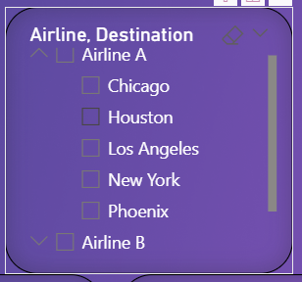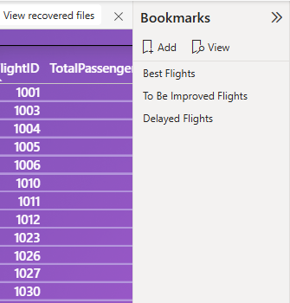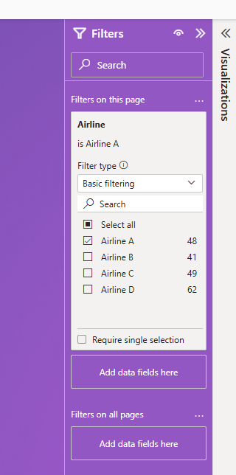


TASL6:FINAL DASHBOARD AND POWER BI SERVICES
1.FINAL DASHBOARD:
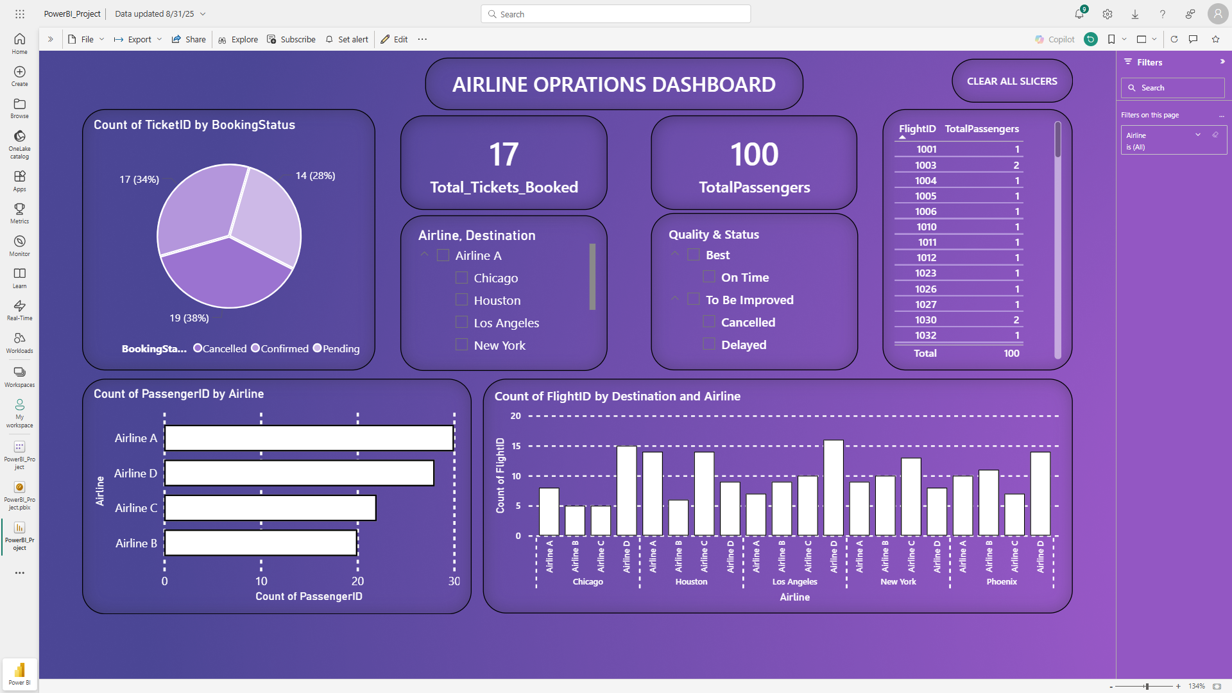
2. RLS ASSIGNED TO A USER FOR AIRLINE A 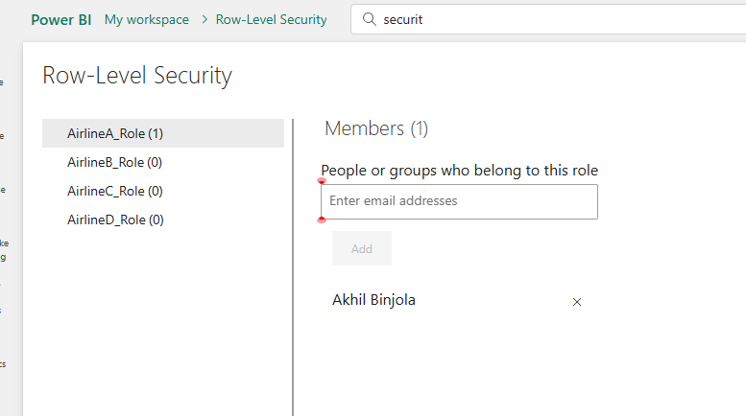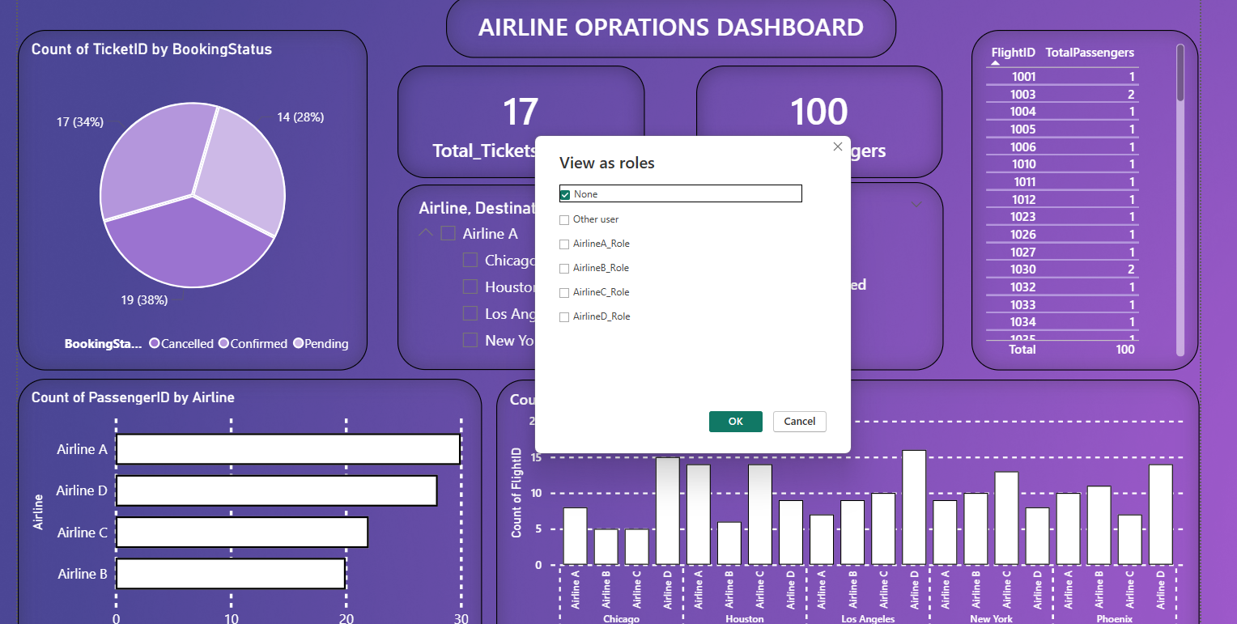

3.SHEDULE REFRESH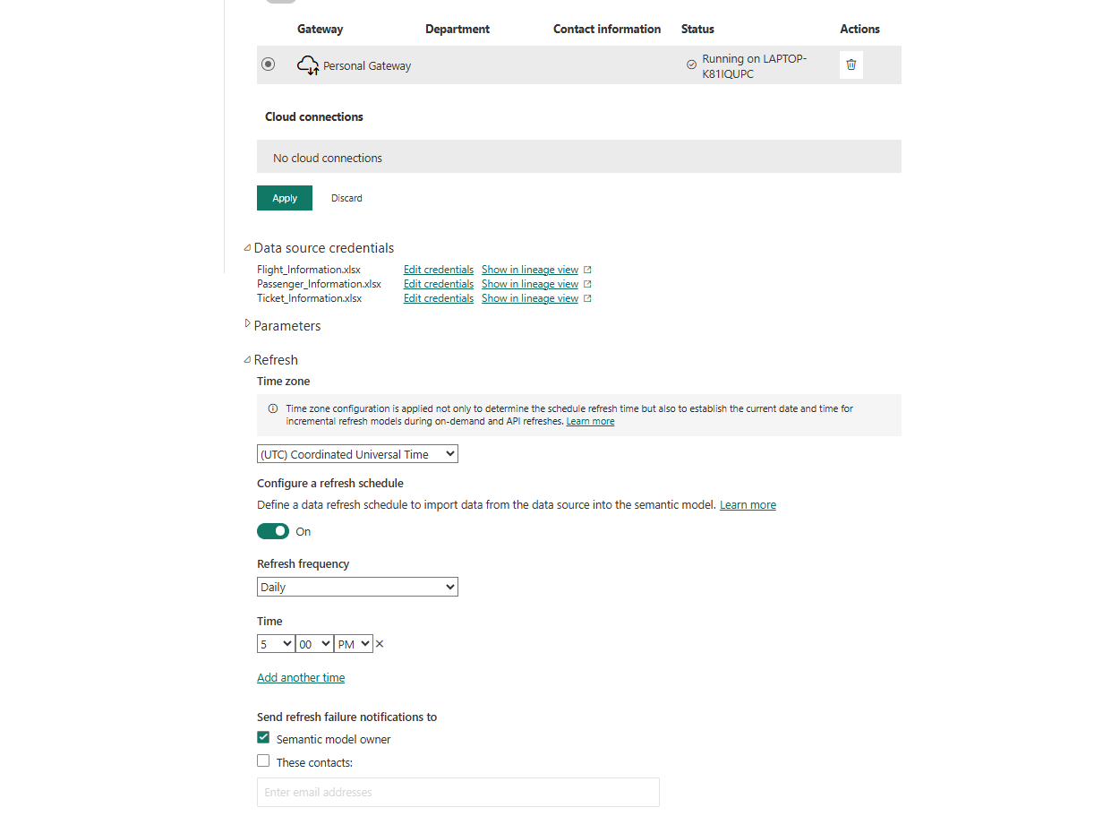

THANK YOU

